Installation of java 8

Installation of Jenkins.war file
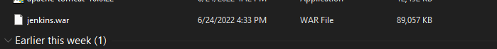

Turning ON Jenkins service
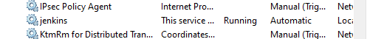

Jenkins is ready on port 8080
